**Diffraction by an infinite long slit**

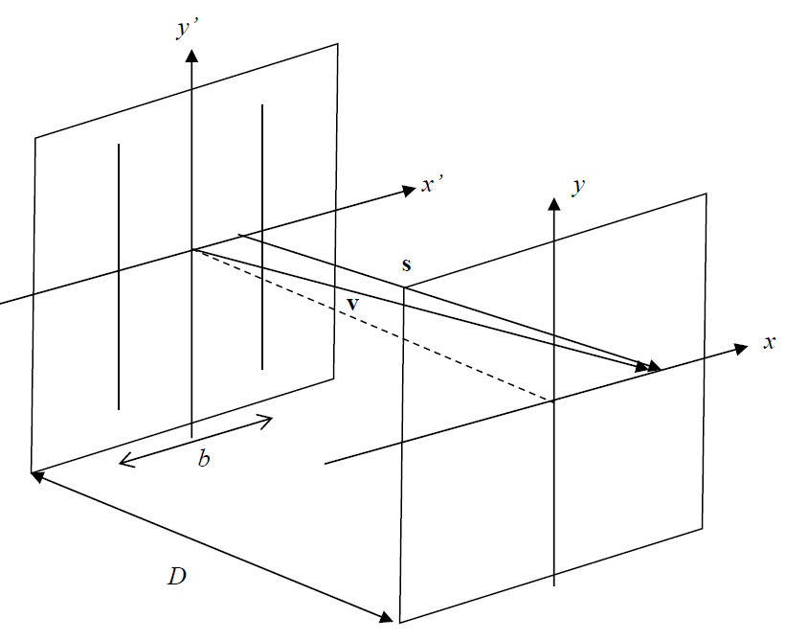

x

x'

a)Draw a normal line from x’-y’ coordinate to x-y coordinate.

Now we have three intersection points at x’-y’plane, starting from these three points, we have three vectors pointing to a same point in x-y plane. These three vectors are $\vec{v}$, $\vec{s}$,and $\vec{n}$.Here $\vec{v}$, $\vec{s}$,and $\vec{n}$ denote to the unit vector in these three directions.

It is trivial to find the geometric relations between these three,

$$\vec{n}∙\vec{s}=\frac{D}{s}$$

$$s=\sqrt{{(x-x')}^{2}+D^{2}}$$

Insert these two equations into (B.5),

$$u\left(x\right)=-\frac{ikA}{4π}\int_{-\frac{b}{2}}^{\frac{b}{2}}{\frac{e^{iks}}{s}\left(1+\vec{n}∙\vec{s}\right)dx^{'}}=-\frac{ikA}{4π}\int_{-\frac{b}{2}}^{\frac{b}{2}}{\frac{\sqrt{{(x-x')}^{2}+D^{2}}+D}{{(x-x')}^{2}+D^{2}}exp⁡(ik\sqrt{{(x-x')}^{2}+D^{2}})dx^{'}}$$

b)

From (B.6) we have

$$I\left(x\right)= {|u(x)|}^{2}=\frac{1}{4}×({\frac{Ab}{Dλ})}^{2}×{(\frac{D}{b})}^{2}{\left|\int_{-b/2}^{b/2}{\frac{\sqrt{{(x-x')}^{2}+D^{2}}+D}{{(x-x')}^{2}+D^{2}}exp⁡(ik\sqrt{{(x-x')}^{2}+D^{2}})dx^{'}}\right|}^{2}$$

The above equation can be written into

$$I\left(x\right)=\frac{1}{4}I_{Frau}(0){\left|\frac{1}{b}\int_{-b/2}^{b/2}{\frac{\sqrt{{(x-x')}^{2}/D^{2}+1}+1}{{(x-x')}^{2}/D^{2}+1}exp⁡(ik\sqrt{{(x-x')}^{2}+D^{2}})dx^{'}}\right|}^{2}$$

Rescale it in spatial, from [-b/2, b/2] to [-1/2, 1/2],

Finally, the intensity distribution in image space becomes

$$I\left(x\right)=\frac{1}{4}I_{Frau}(0){\left|\int_{-1/2}^{1/2}{\frac{\sqrt{{(x-x')}^{2}/D^{2}+1}+1}{{(x-x')}^{2}/D^{2}+1}exp⁡(ik\sqrt{{(x-x')}^{2}+D^{2}})dx^{'}}\right|}^{2}$$

This is what it was asked to probe in question b, the question (B.14).

c)

In Fraunhofer diffraction, by performing variable substitution and approximation in (B.7), (B.8) and (B.13), we have

$$\frac{I_{Frau}(θ)}{I_{Frau}(0)}=\cos^{2}θ\cos^{4}\frac{θ}{2}{\left(\frac{sinβ}{β}\right)}^{2}$$

Where

$$tanθ=\frac{x}{D}$$

$$β=\frac{1}{2}kbsinθ$$

Below are the plotting results,

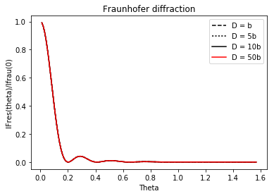

In Fresnel diffraction, the problem becomes to calculate the below integral,

$$I\left(x\right)=\frac{1}{4}I_{Frau}(0){\left|\int_{-1/2}^{1/2}{\frac{\sqrt{{(x-x')}^{2}/D^{2}+1}+1}{{(x-x')}^{2}/D^{2}+1}exp⁡(ik\sqrt{{(x-x')}^{2}+D^{2}})dx^{'}}\right|}^{2}$$

Use Gaussian quadrature to calculate this integral, and plot it as below,

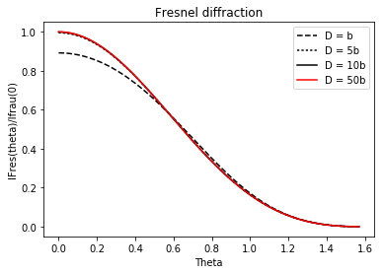

Put them together,

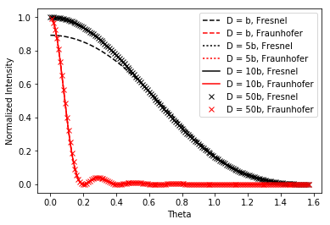

Here, for Fraunhofer diffraction, the approximation for the integral assuming D>>b. The different D conditions here are meaningless, and the plotting results should be same.

For Fresnel diffraction, it is noticed that all these D conditions making the center of the imaging plane have optical path difference to the aperture in even times of $π$. So we see that all the Fresnel diffraction plotting have maxima at $θ=0$.

**Diffraction by a square aperture**



x

x'

In the two dimensional case, s is composed by x, y and z (the light propagation direction) three directions.

We have

$$s=\sqrt{D^{2}+{(x-x')}^{2}+{(y-y')}^{2}}$$

$$u\left(x,y\right)=-\frac{ikA}{4π}\int_{-\frac{a}{2}}^{\frac{a}{2}}{\int_{-\frac{a}{2}}^{\frac{a}{2}}{\frac{e^{iks}}{s}\left(1+\vec{n}∙\vec{s}\right)dx^{'}dy^{'}}}=-\frac{ikA}{4π}\int_{-\frac{a}{2}}^{\frac{a}{2}}{\int_{-\frac{a}{2}}^{\frac{a}{2}}{\frac{\sqrt{{\left(x-x^{'}\right)}^{2}+{\left(y-y^{'}\right)}^{2}+D^{2}}+D}{{\left(x-x^{'}\right)}^{2}+{\left(y-y^{'}\right)}^{2}+D^{2}}\exp\left(ik\sqrt{{\left(x-x^{'}\right)}^{2}+{\left(y-y^{'}\right)}^{2}+D^{2}}\right)dx^{'}}}dy'$$

By definition, I = u2

Use Gaussian quadrature to calculate this integral, and plot the contour as below (Left in natural scales, right in log scale),

(Set A = 1)



D = 0.1a case, it is noticed that the distance between the aperture and the imaging plane is even less than one wavelength. For the center area, the optical path difference (OPD) is

$$∆φ=kD=π$$

So the center area should be dim. On the other hand, at the periphery of the center areas where the OPD equal to $2π$, the intensity is brighter.

 

Similar analysis can be performed on D=0.5a case. Here the OPD is

$$∆φ=kD=5π$$

Since this is a second odd times of $π$, the center area should also be dim. And the first bright area is symmetric where the OPD equal to $6π$.

For D = a, D=5a, D = 20a cases, the distance between the aperture to the center of the imaging is much larger than the wavelength scale. Here the Fraunhofer approximation works well that the diffraction pattern looks like Figure IIIB.

 

  